# Media Analysis - Is the Arab world ready for the uncertain age of AI-powered web tools

## Short Summary

The global AI market is projected to reach 15.7 trillion by 2030, primarily driven by the Middle East's significant contribution, emphasizing that while AI enhances efficiency in tasks like content creation and customer service, it does not replace human creativity or analytical skills.

## Summary

The global market value of AI, estimated at 1  
5.7 trillion in 2030, is expected to contribute significantly to the global economy by then. This growth is projected to be 97 million people working in AI by 2024 and a 13x increase over the next eight years.  
AI's impact extends beyond search engines; it's anticipated that 2 percent of the world's benefits from AI by the end of this decade, equivalent to 320 billion, with the Middle East expected to partake in this growth.  
While tools like ChatGPT can be useful for simplifying tasks and providing engaging content, experts stress the importance of fact-checking due to its potential for misinformation. AI models, such as large-language models (LLMs), are not capable of understanding context or reasoning in a conventional sense; they simply match patterns based on training data.  
Despite these capabilities, human intelligence and awareness remain essential for the safe expansion of AI use. The UAE Minister of Education acknowledged the potential of ChatGPT to assist in content creation but reassured that it cannot replace creativity or human insight found in human writers.  
The debate surrounding AI's impact remains divided, with optimists believing it will augment human capabilities and pessimists fearing widespread automation could lead to job displacement. Regardless of the perspectives, trust is crucial for the ethical integration of AI solutions into society.  
In conclusion, while AI holds immense investment potential with forecasts valuing in trillions of dollars, it's essential to address concerns about misinformation and maintain human involvement to ensure a safe and beneficial use of AI technologies worldwide.

## Question 1:

How do the media in this article frame the public discussion about ChatGPT? Are there certain **metaphors** that keep cropping up?

The media frames the public discussion about ChatGPT using metaphors that emphasize its role as a simplifier and fun tool, text generator or writer, source of information, limitations compared to human writers, potential for misuse in education, and a blend of optimism and pessimism regarding its impact on society.

## Question 2:

Which role does or might the Arabic World play in the development of Artificial Intelligence? Answer with 'Not mentioned' if not applicable.

The Arabic World, particularly countries like the UAE, has shown significant interest and investment in AI, indicating a potential for contributing or playing a key role in its development and application.

## Question 3:

Which use cases of Artificial Intelligence are helpful for the Arabic world based on this article?

1. Content Creation ChatGPT, which can assist in creating various types of content such as social media posts, blogs, reports, emails, legal documents, and summaries, can help improve communication and writing in the Arabic language.

## Question 4:

What is the final message of the article that the author wants to convey? Keep your answer short and precise!

AI is a valuable tool, but its limitations must be recognized. It should be used thoughtfully and with trust, acknowledging that humans remain crucial in areas like creativity, skepticism, and reasoning.

## Sentiment

The sentiment is 5

## Entities

Multinational Tech Corporation Microsoft, Chatgpt O Ere Measure Reassurance, Nancial Support Tech Industry, Linkedin Co, Uk Guardian Newspaper Say, Jenna Burrell, Marketing Professional Redundant Technology, Sciences Po School Paris, Research Data Society Independent Non Pro T Research Organization Base California Say People Need, Dan Milmo Alex Hern Tech, Reid Ho, Burrell Say, Chatgpt Spur Google Management, James Webb, Eld Seek, Sam Altman Year, Omar Sultan Al Olama Take, Spearhead Uae Expand Digital Economy Middle East Project Accrue Percent Total Global Bene, Ahmed Belhoul, Initial Investment Rm Worth Billion Billion Mean Company Value, Elon Musk Serve Start Board, Arab News Leap Technology Conference, Noaman Sayed, Education Chatgpt Say Program Assist Content Creation Social Medium Blog Website Write Business Plan, Peter Thiel Tesla

## Topic Clusters

### Cluster: AI Technology & ChatGPT

Arabic newspaper articles discussing AI and its applications, Evaluation of ChatGPT's capabilities and limitations, Societal implications of using advanced AI technologies

### Cluster: General Discussions on AI

Public perception and understanding of AI, Concerns about the potential misuse of AI, Regulatory measures for AI development and deployment

## Word Clouds

### Wordcloud of content

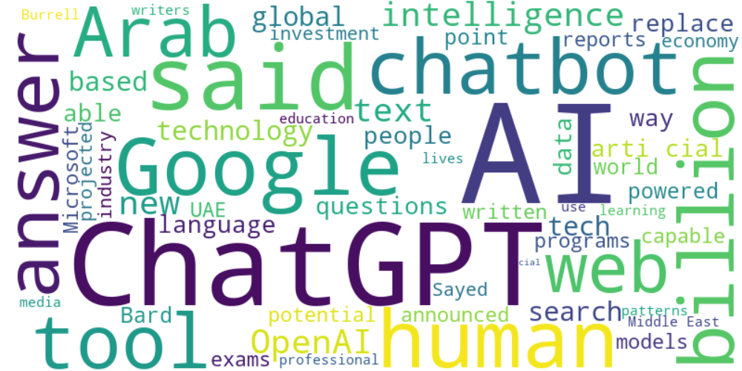

Top 10 words:

- AI: 27

- ChatGPT: 18

- said: 10

- human: 8

- Google: 8

- billion: 7

- Arab: 6

- web: 6

- intelligence: 6

- OpenAI: 6

### Wordcloud of summary

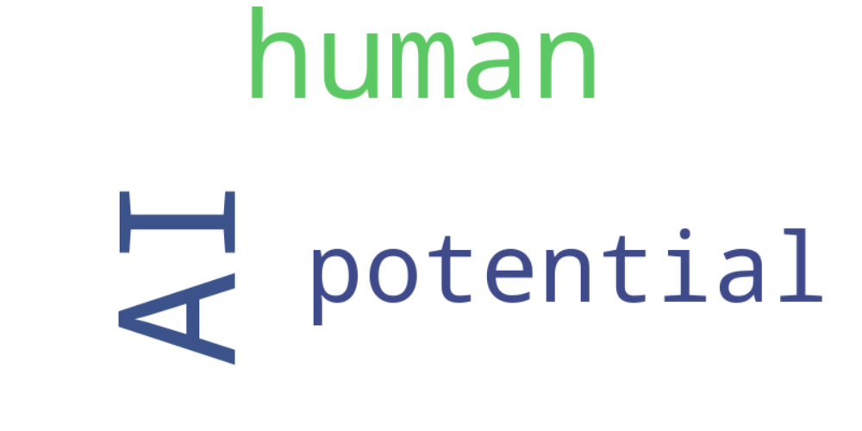

Top 10 words:

- AI: 10

- human: 5

- potential: 3